Installing ArcGIS Desktop 10.4 Education Edition

Step 1: Create Your ESRI Account  Step 1(a): go to http://www.esri.com/EducationEdition to Register for a Free Trial version of ArcGIS | 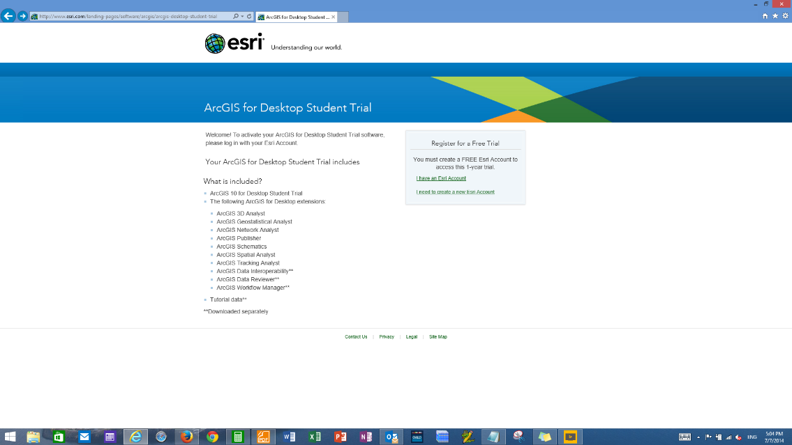
Step 1(b): If you already have an ESRI Account click on “I have an Esri Account” to sign in to your account; if you do not have an ESRI account click on “I need to create a new Esri Account”. | 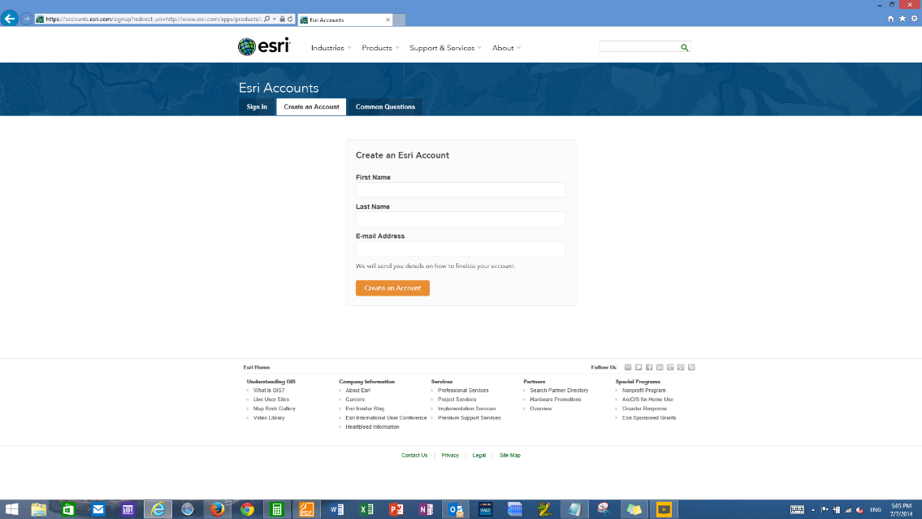
Step 1(c): Verify your email address | 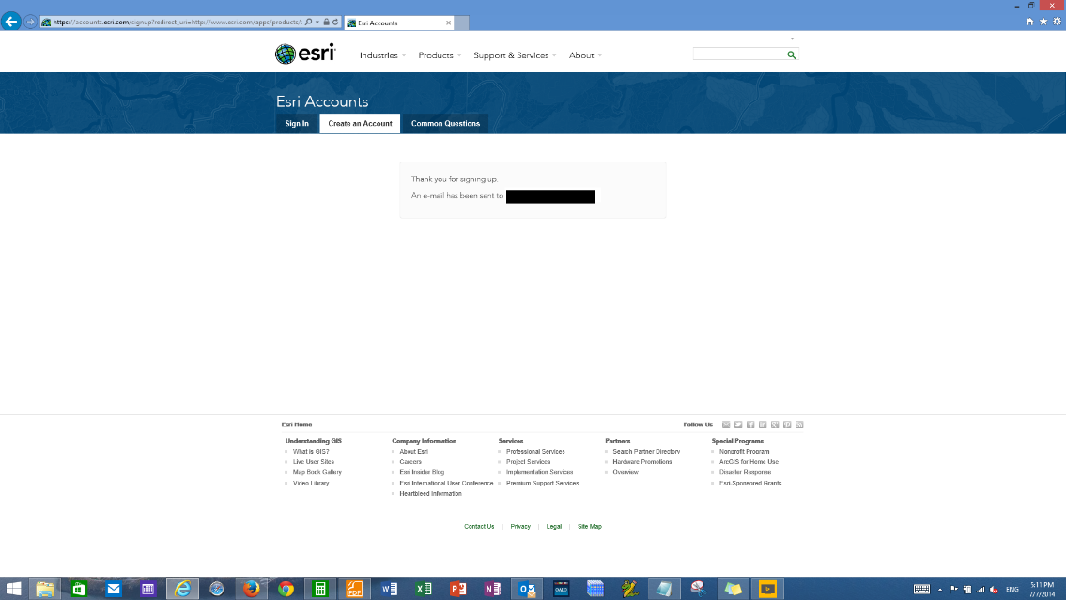
Step 1(d): Create your log in information (i.e. username and password) | 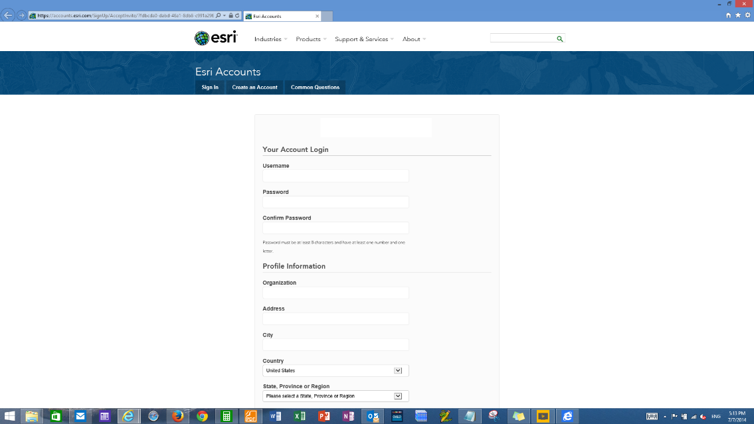
Step 2: Log in to your Account | 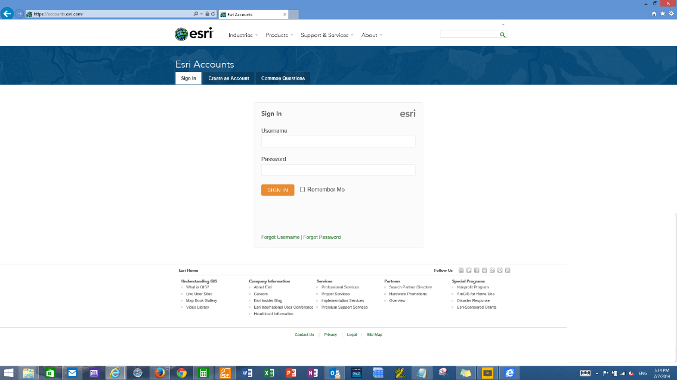
Step 3: Activate your Evaluation License EVA######## | 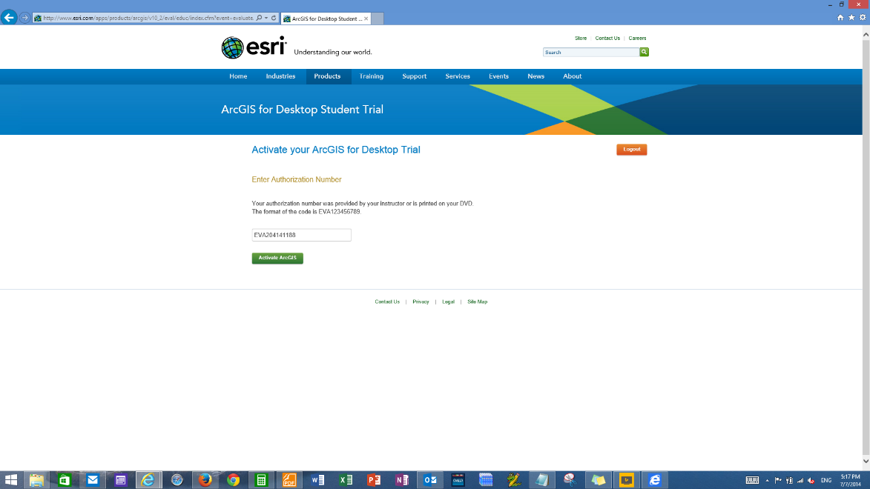
Step 4: Select your ArcGIS version (e.g. ArcGIS 10.4 for Desktop) | 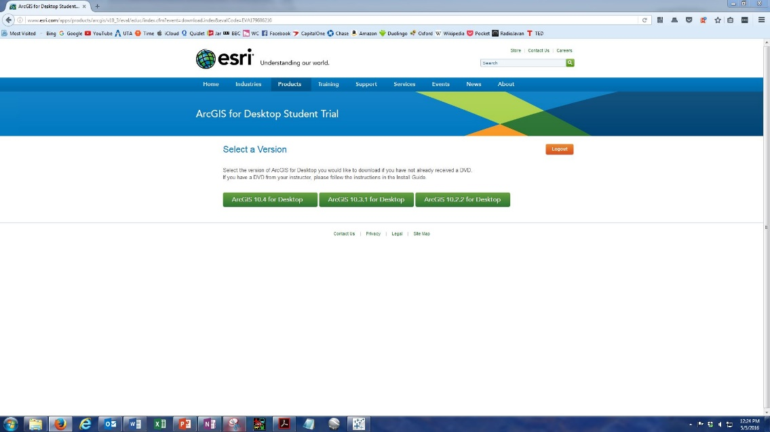
Step 5: Download “ArcGIS for Desktop” (Note: other downloads are optional) | 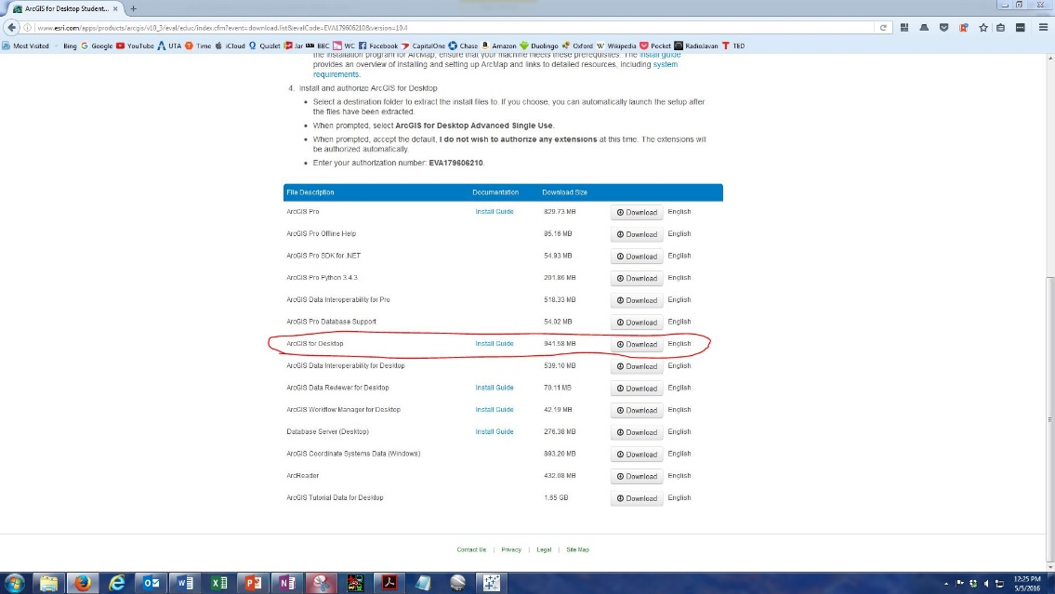
Step 6: Extract package

Step 6(a): Double-click to extract the package
Step 6(b): Choose extract destination and click “OK” | 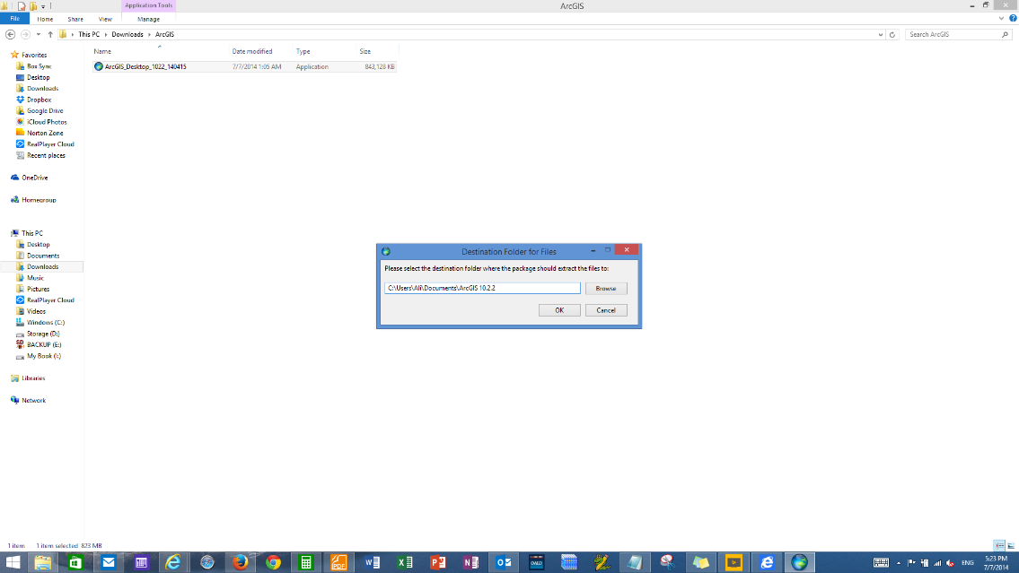
Step 6(c) | 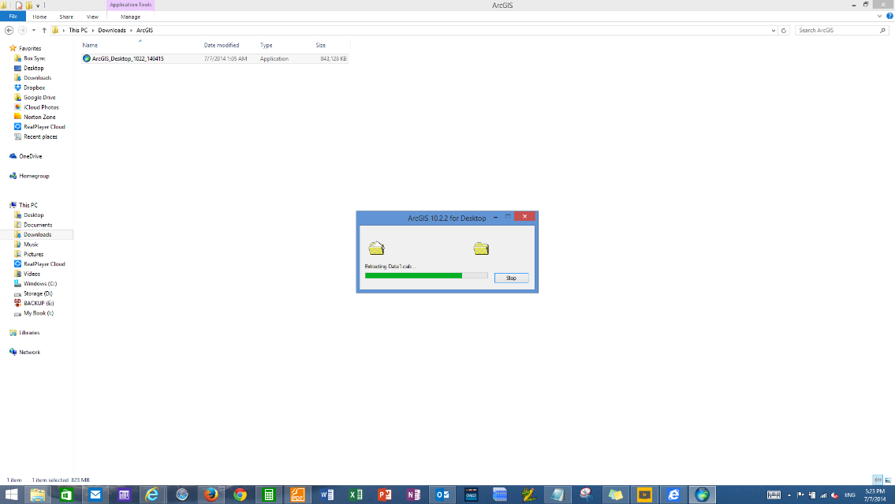
Step 6(d): Select the “Lunch the setup program” option and click “Close” to go to installation process. | 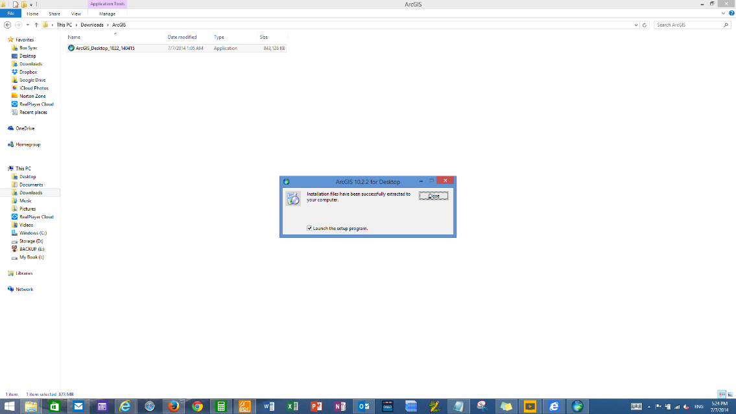
Step 7: Install Software  Step 7 (a): Click “Next” | 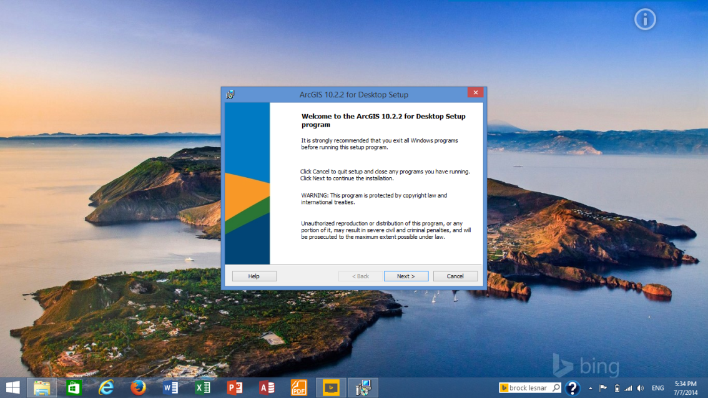
Step 7 (b): select “I accept the License Agreement” option and click “Next” | 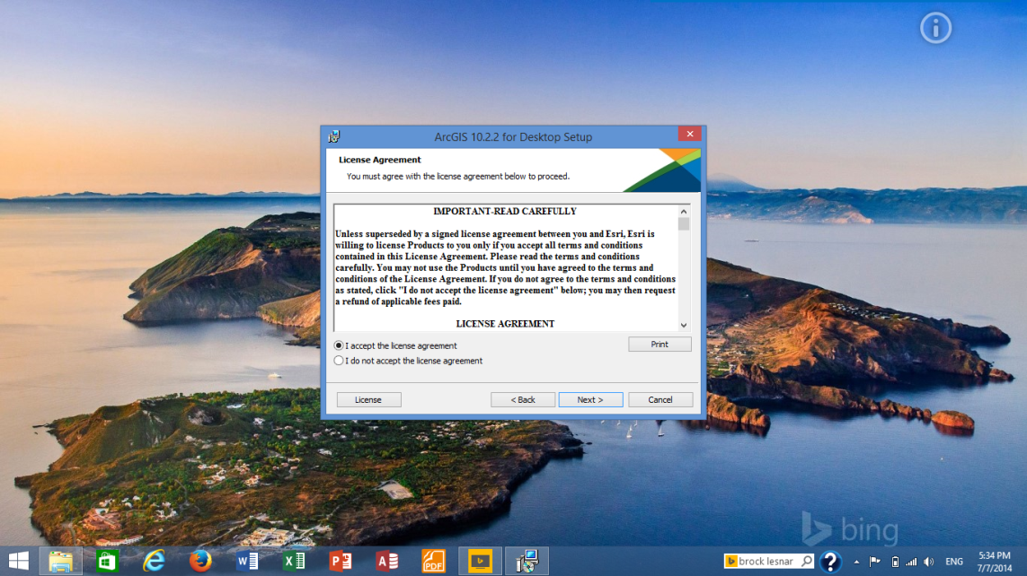
Step 7 (c): Select “Complete” option and click “Next” | 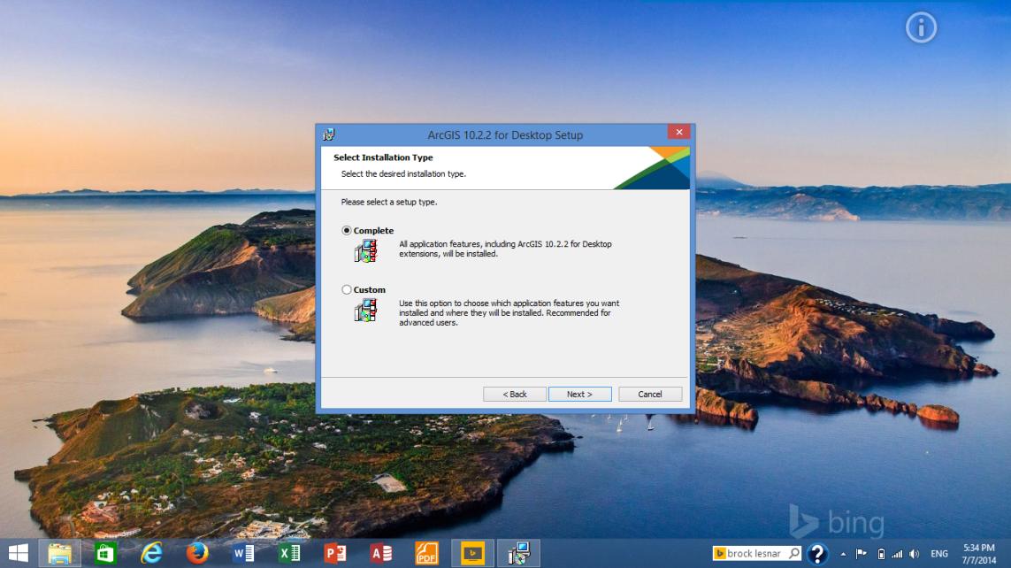
Step 7 (d): Accept default destination folder and click “Next” | 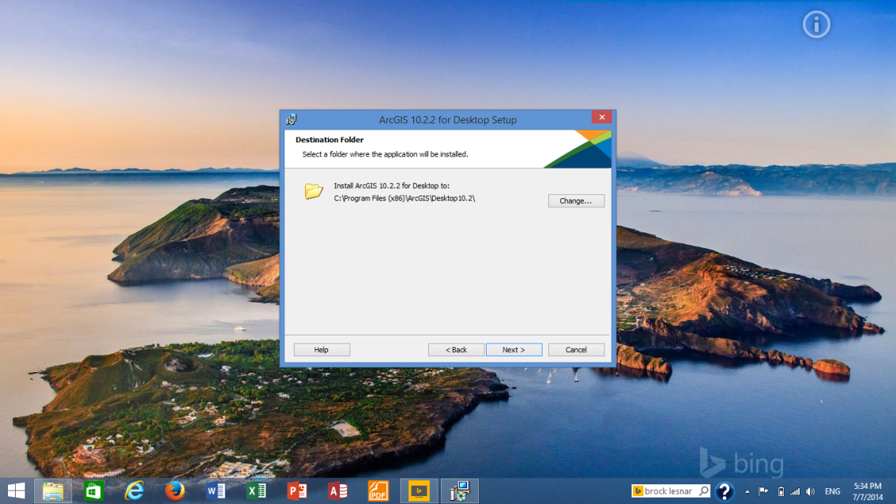
Step 7 (e):  Do not change destination folder for Python and click “Next” | 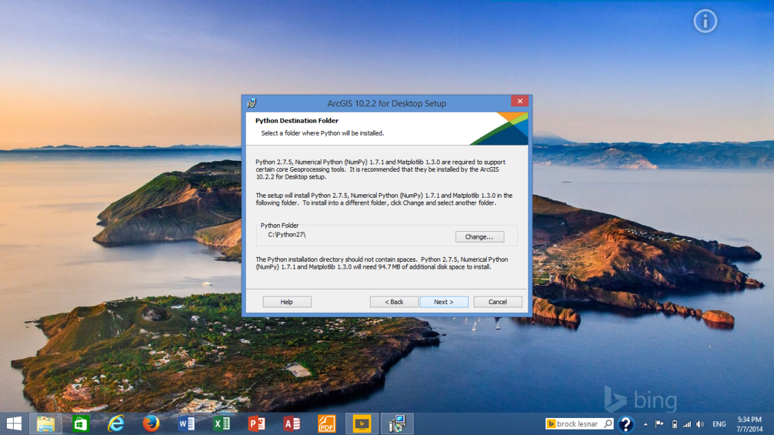
Step 7 (g): Select “Click here to participate …. (Recommended)” and Click “Install” | 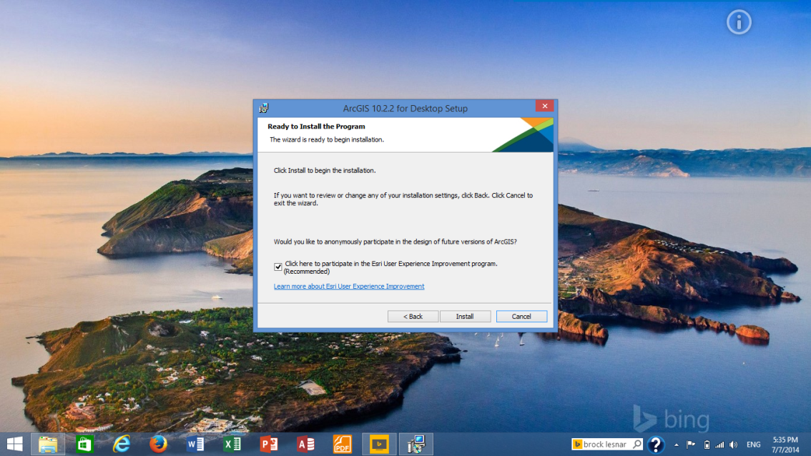
Step 7 (h): Click “Finish” and wait until “ArcGIS Administrator Wizard” pops up. (See step 8) | 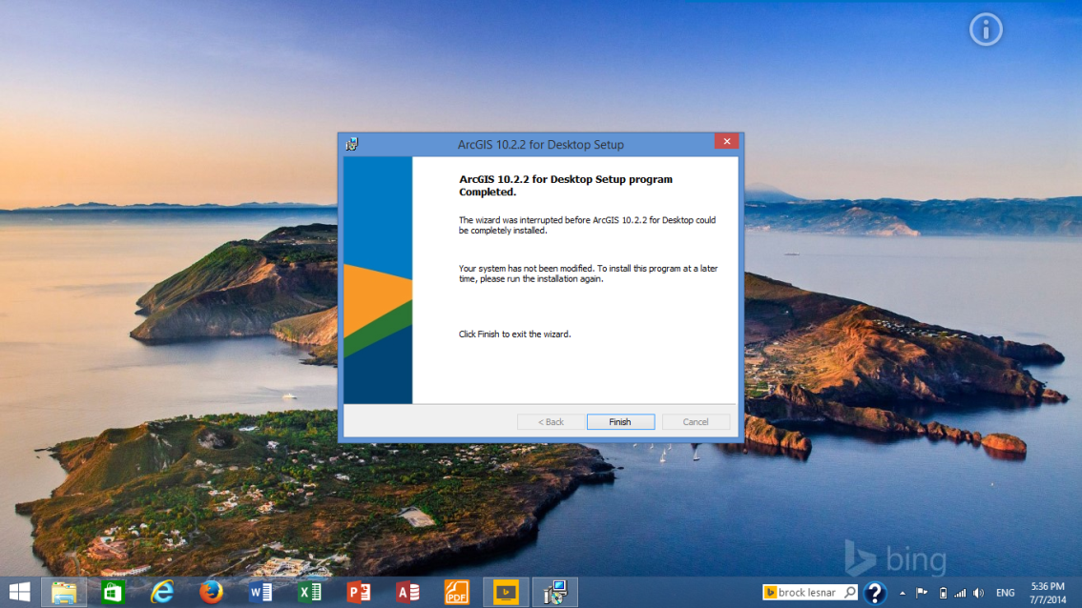
Step 8: Authorize Software | 